Salt Lake Community College, Chemistry Department
Chem 1110 Workshop 4
Topic: Ionic Compounds

Objective:
- Ions and Ionic compounds
- Ions of Some Common Elements
- Empirical Formula
- Lewis dot structure
- Formulas of Ionic Compounds
Ions:
- Ions - atoms with an electrical charge
- In general: metal atoms tend to lose electrons to form cations, nonmetal atoms tend to gain electrons to form anions.
Ionic Compounds:
The behavior of the atoms in forming bonds or ions can be predicted by their position in the Periodic Table.
- Is the element a metal or a nonmetal?
- Of which group is the element a member?
- Ionic compounds – usually combinations of metals and nonmetals, NaCl.
Ions of Some Common Elements:

atom Na: 11 e⁻; the closest noble gas Ne: 10 e–
atom Na − 1 e − → Na⁺ (metal)

atom Cl: 17 e⁻; the closest noble gas Ar: 18 e⁻
atom Cl + 1 e⁻ → Cl⁻ (nonmetal)
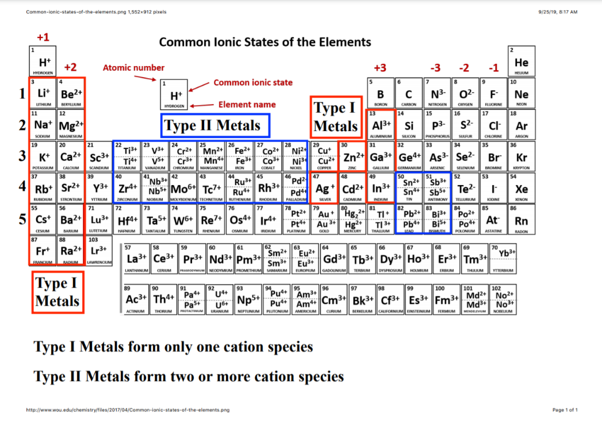

Empirical Formula:

The empirical formula of a compound is the simplest whole number ratio of atoms in the compound. Remember: the total charge of a compound is zero.

Lewis electron dot structures (Lewis structures) for atoms
A. Lewis structures generally consist of the elemental symbol surrounded by one dot for each valence electron of the substance
B. Valence electrons are the outer shell s and p electrons

Practice problems:

1.Write the Empirical Formula of the following ionic compounds formed by:

  - Al³⁺ and O²⁻ -> Al₂O₃

  - Mg²⁺ and NO₃⁻ Mg(NO₃)₂

  - Cr³⁺ and Cl⁻ CrCl₃

  - Fe³⁺ and Br⁻ FeBr₃

  - Ca²⁺ and O²⁻ CaO

- Identify the valence electrons in the following elements and draw Lewis Dot structure:

Elements | Valence Electrons | Lewis Dot Structure
K | 1 | Kꞏ
Ca | 2 | ꞏCaꞏ
Al | 3 | ∙Al∙ (3 dots)
Ba | 2 | ꞏBaꞏ
Na | 1 | Naꞏ

- Determine the charge on each atom for the following ionic compounds:

Ionic Compounds | Metal (Cation) | Nonmetal (Anion)
CrCl₃ | Cr³⁺ | Cl⁻
FeO | Fe²⁺ | O²⁻
TiO₂ | Ti⁴⁺ | O²⁻
PbBr₂ | Pb²⁺ | Br⁻
Al₂O₃ | Al³⁺ | O²⁻

- Using Lewis symbols, write the reaction formation of the following:

 | Lewis dot Structure + Lewis dot Structure  (Metal) (Non-Metal) | Reaction Formation (Ionic Compound)
NaCl from Na and Cl | Naꞏ + Cl (7 dots) | Na⁺[Cl (8 dots)]⁻
CaS from Ca and S | ꞏCaꞏ + S (6 dots) | Ca²⁺[S (8 dots)]²⁻

