Salt Lake Community College, Chemistry Department

Chemistry Workshop 2

Topic: Atoms and the periodic table

Objective

- Atomic Number, Isotopes and Atomic Weight

- Some Characteristics of Different Groups

- Ions

- The Periodic Table

- Electronic Structure of Atoms and Electron Configurations

Atomic Number:

What does atomic number tell us? Gives us the number of protons in an atom!

Symbol of element

12C⁶

2.Mass number (number of

protons and neutrons)

1.Atomic number (Number of electrons and protons)

  - Atomic number - the top number for each element in the Periodic Table, Abbreviated "Z"
  - Mass number abbreviated “A”

- In their elemental state elements are electrically neutral, in each atom the #e⁻ = #p⁺

Isotopes and Atomic weight:

- Isotopes: substances with the same number of protons but different numbers of neutrons

- The bottom number in the Periodic Table for each element is the atomic weight, the weighted average of the atomic masses of all the isotopes

Ions:

- Ions - atoms with an electrical charge

- In general: metal atoms tend to lose electrons to form cations, nonmetal atoms tend to gain electrons to form anions.

The periodic table:

- Alkali Metals (Group 1A): Li, Na, K, Rb, Cs, Fr

1. Shiny, soft metals with low melting point
2. React with water to form products (reactivity → unstable)

3. Because of their high reactivity, alkali metals are never found in nature in a pure form.

- Alkaline Earth Metals (Group 2A): Be, Mg, Ca, Sr, Ba, Ra

- Shiny, silver metals

- Less reactive than their neighbors in group 1A

- Never found in nature in a pure state

- Metalloids: B, Si, Ge, Sb, Te, Po, At

1. Mixed properties (semi- conductors)

2. Solid at room temperature. They can lose or gain electrons.

- Halogens (Group 7A): F, Cl, Br, I, At

- Colorful and corrosive nonmetals

- Found in nature only in combination with other elements such as NaCl

- Noble gases (Group 8A): He, Ne, Ar, Kr, Xe, Rn

1. Colorless gases

2. Label noble gases because their lack of reactivity (stable**8 valence electrons→ nonreactivity)

3. Do not combine with other elements.

Electronic Structure of Atoms and Electron Configurations

- Electrons cannot exist just anywhere with respect to the nucleus; they can only be found at certain specific distances from the nucleus.
- Areas of high probability are called orbitals

- The discrete distances at which electrons can be found from the nucleus can be broken down into shells, subshells, and orbitals
  - Shell

    - Describes distance from nucleus

    - As n increases, distance increases

    - The spacing between shells is not linear

  - Subshell

    - Each shell contains as many subshells as its number

  - Any orbital can only hold a maximum of two electrons

shell (n) |  | subshell (l) | # orbitals | #electrons | total electrons
 |  |  |  | /orbital
1 |  | s | 1 | 2 | 2
2 |  | s, p | 1+3=4 | 2 | 8
3 |  | s, p, d | 1+3+5=9 | 2 | 18
4 |  | s, p, d, f | 1+3+5+7=16 | 2 | 32

- Ground state and excited electrons

  - Electrons in their lowest energy state are said to be in the ground state

Electron Configuration:

Below is a simple scheme to help remember the order in which the orbitals are filled.
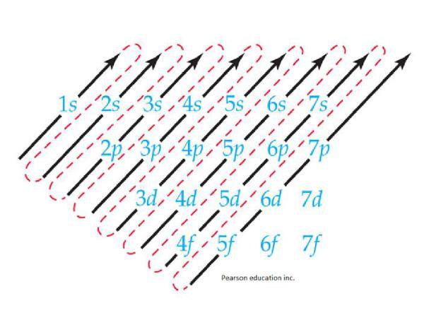

Practice Problems

- Three kinds of particles are present in atoms.

  - Which particle in an atom has the smallest mass? Electron

  - Which particle in an atom is not present in the nucleus? Electron

  - Which particle in an atom has a positive charge? Proton

- Which atomic particle determines the chemical behavior of an atom? Electron

- Give the number of protons (p⁺), the number of neutrons (n⁰), and the number of electrons (e⁻) in one atom of:

Element | p⁺ | n⁰ | e⁻
²³Na₁₁ | 11 | 12 | 11
¹⁹ F₉ | 9 | 10 | 9
³⁹K₁₉ | 19 | 20 | 19

- A certain isotope X³⁺ contains 41 electrons and 23 neutrons. What is the mass number of this element?

Charge = p⁺ - e⁻
3+ = p⁺ - 41 Solve for p⁺
p⁺ = 44
Mass number (A) = p⁺ + n⁰ = 44+ 23 = 67 amu

- Give the chemical symbol and the mass number for the ion with 22 protons, 26 neutrons and 19 electrons?

A= 48 amu, ²²Ti³⁺

- How many protons, neutrons and electrons are in one ion of 79³⁴ Se ²⁻ ?
p⁺ = 34
e⁻ = 36
n⁰ = 45

Element/Ions | Ground state Electron Configuration
Se | 1s²2s²2p⁶3s²3p⁶4s²3d¹⁰4p⁴
Al | 1s²2s²2p⁶3s²3p¹
S²⁻ | 1s²2s²2p⁶3s²3p⁶
Cr⁺ | 1s²2s²2p⁶3s²3p⁶3d⁵
Give the complete ground-state electron configuration of: (do not use the inert-gas abbreviation

7. The element with the electron configuration

1s² 2s² 2p⁶ 3s² 3p⁶ 4s¹ is

  - Rb.
  - Ar.
  - Ca.

  - K.
  - Mg.

- Write the noble gas configuration for C, N, and Ca?

Element | Noble gas configuration
C | [He]2s²2p²
N | [He]2s²2p³
Ca | [Ar]4s²
Na | [Ne]4s¹

