Salt Lake Community College, Chemistry Department
Chem 1110 Workshop 13
Topic: Nuclear Chemistry
Objective:
- To be able to write and balance equations for nuclear reactions
- To understand and be able to list the characteristics of the three common kinds of nuclear radiation
- To be able to explain half-life and calculate quantity of radioisotope remaining after a given number of half-lives
Practice Problems:
- The emission of a particle from an unstable nucleus is called __nuclear decay___________.

- The change of element into another by the process of nuclear decay is called ___transmutation__________.

- The term nucleon refers to____protons and neutrons_________.

- Radioactivity is generally associated with which part of the atom?
A) nucleus
B) electrons
C) protons
D) neutrons
E) the entire atom

5. Which nuclear reaction is not balanced?
A) 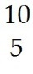B + He → 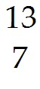N + n
B) 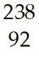U + He → 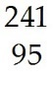Am + n
C) 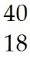Ar + H → 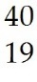K + n
D) 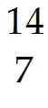N + He → 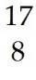O + H

6. Which product is formed by beta emission from phosphorus -32? The atomic number of phosphorus is 15.
A) 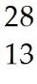Al
B) 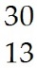Al
C) 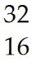S
D) 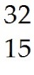P
E) 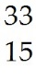P

- What is the missing reactant in the reaction shown?

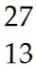Al + ________ → 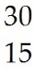P + n

A) He
B) H
C) H
D) n
E) 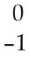β

8.Which reaction is an example of a gamma emission?
A) 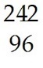Cm → 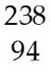Pu + He
B) B + n → Li + He
C) 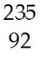U + n → 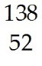Te + 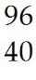Zr + 2 n
D) 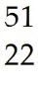Ti → 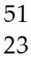V + 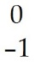β
E) 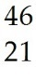Sc → Sc + energy

- Iodine-131 has a half-life of 8.0 days. If you originally have a 658 g sample of Iodine-131, how much will remain after 32 days?

(1/2)^{# of half lives} = amount remaining/ original amount

1 half life = 8.0 days
32 days x 1 half life/ 8.0 days = 4 half lives
(1/2)⁴ = x / 658 g
0.0625 = x/ 658 g
41.1 g = amount remaining

