Salt Lake Community College, Chemistry Department
Chem 1110 Workshop 12
Topic: Acids and Bases Part II
Objective:
- Buffer Solutions
- To be able to make calculations of titrations and concentration of acids
- Acidity and Basicity of Salt Solutions
Buffer: A combination of substances that act together to prevent a drastic change in pH; usually a weak acid and its conjugate base
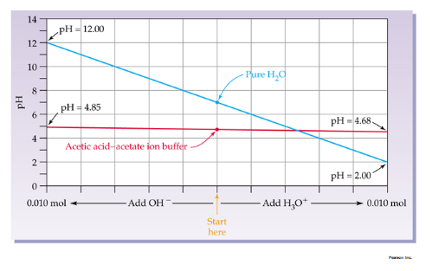
Acid- Base Titration:
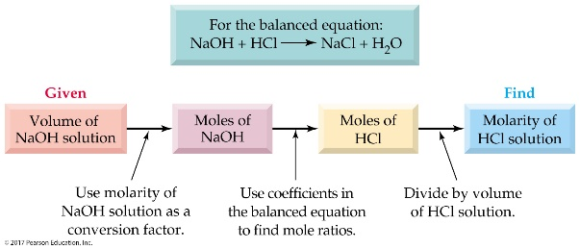
Acidity and Basicity of Salt Solutions:
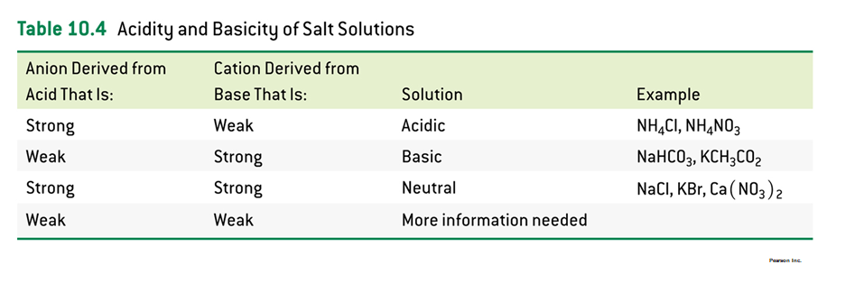
Practice Problems:
- Find [H₃O⁺] and the pH in a solution prepared by dissolving 0.900 g of Ca(OH)₂ in water and diluting the solution to a final volume of 800 mL.
Ca(OH)₂ Ca²⁺ + 2 OH⁻
Step 1: mass moles (/ MM)
0.900 g x 1 mol/ 74 g = 0.0122 mol Ca(OH)₂
Step 2: moles/ V (L) = M
0.0122 mol Ca(OH)₂ / 0.800 L = 0.0153 M
[OH⁻] = 2 (0.0153) = 0.0306 M
Step 3: pOH= - log [OH⁻]
= - log (0.0306) = 1.5
pH + pOH = 14 = 12.5
[H⁺] = 10^{-pH} = 3.2 x 10⁻¹³ M
2. What is the pH of a solution prepared by dissolving 150.0 g KOH in enough water to make 7.867 L solution? KOH K⁺ + OH⁻
150.0 g KOH x 1 mole/ 56.08 g = 2.67 mole KOH , 2.67 mol [OH⁻]
M= moles of solute/ Liters of solution = 2.67 mol/ 7.867 L= 0.339 M_{[OH-]}
pOH = - log [OH⁻] = 0.47
pH + pOH = 14
pH = 13.5
3. What volume of 0.100 M NaOH (aq) is needed to titrate 200.0 mL of 0.200 M H₂SO₄ (aq) to the neutralization point?
2 NaOH + H₂SO₄ Na₂SO₄ + 2 H₂O
M= moles of solute/ Liters of solution
0.200 = moles/ 0.200 L = 0.04 moles H₂SO₄
0.04 moles H₂SO₄ x 2 mol NaOH/ 1 mol H₂SO₄ = 0.08 mol NaOH
M= moles of solute/ Liters of solution
V= mole/ M = 0.08 mol/ 0.100 = 0.800 L NaOH or 800 mL
4. Calculate the pH of a buffer solution containing 0.015 M HClO and 0.025 M ClO⁻.
The K_{a} for HClO is 3.0x10⁻⁸.
pH= pKa + log [ClO⁻]/ [HClO] 7.74
5. For a solution of the weak acid HC₂H₃O₂(aq), state whether the H₃O⁺(aq) concentration will increase, decrease, or stay the same if: (There is no volume change in questions a, b, and c.)
(a) we add some NaC₂H₃O₂ (sodium acetate) _decrease_____ .
(b) we add some HCl _increase______.
(c) we add some NaCl __stay the same____.

