Salt Lake Community College, Chemistry Department
Chem 1110 Workshop 12
Topic: Acids and Bases Part I
Objective:
• Acids and Bases Definitions and Strengths
• To be able to use the pH scale and relate it to [H₃O⁺]
Arrhenius definition of an acid:
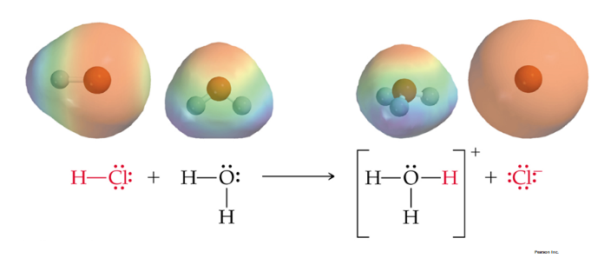
Bronsted Lowry Acid and Base:
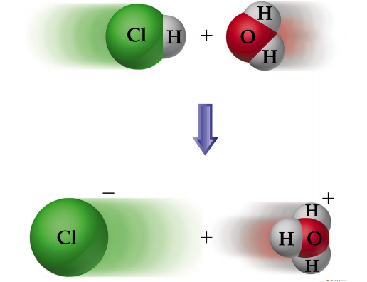
- Brønsted-Lowry: acid donates H⁺ and base accepts H⁺.
- Brønsted-Lowry base does not need to contain OH⁻.
- Water can behave as either an acid or a base.
Acid and Bases Strength:
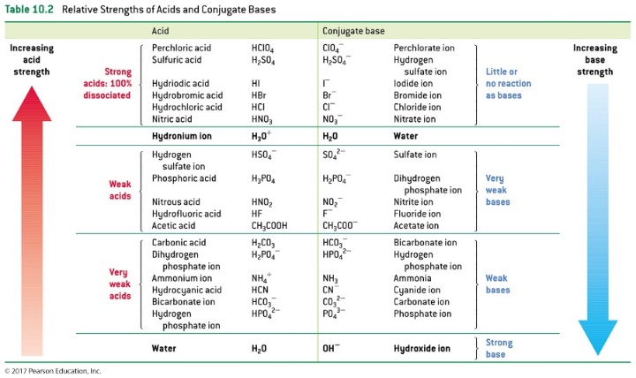
Conjugate Acid-Base Pairs:
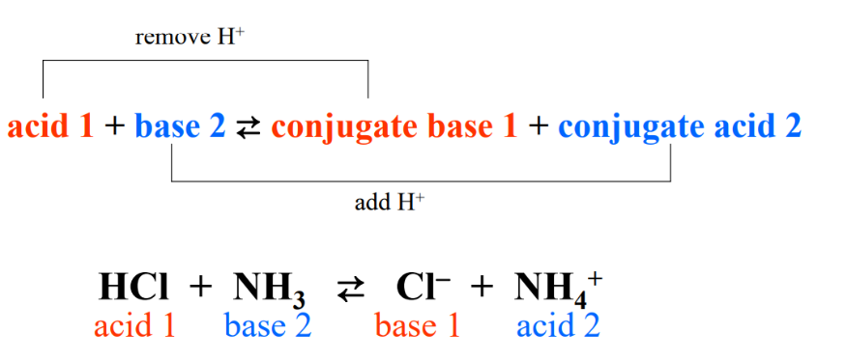

Acid Dissociation Constants:
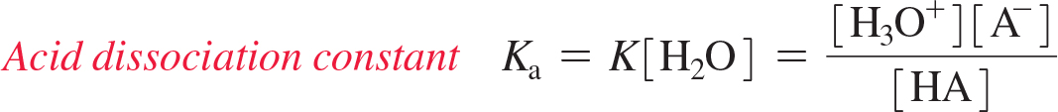
- A special constant Ka is used to represent this equilibrium. - The concentration of water, which is essentially constant, is included in the value of Ka. - Strong acids have large Ka values. Weak acids have small Ka values.
Practice Problems:
1. When acids and bases react the product other than water is a (Acid Base rxn salt + H2O)
- hydrogen ion.
- hydroxide ion.
- hydronium ion.
- metal.
- salt.

2. A Brønsted-Lowry acid is a substance which
- produces hydrogen ions in aqueous solution.
- produces hydroxide ions in aqueous solution.
- donates protons to other substances.
- accepts protons from other substances.
- accepts hydronium ions from other substances.
3. A Brønsted-Lowry base is a substance which
- produces hydrogen ions in aqueous solution.
- produces hydroxide ions in aqueous solution.
- donates protons to other substances.
- accepts protons from other substances.
- accepts hydronium ions from other substances.

4. Classify each of these solutions as Brønsted-Lowry acid or base.
CN⁻ | Brønsted-Lowry Base
HClO₄ | Brønsted-Lowry Acid
PO₄³⁻ | Brønsted-Lowry Base
HBr | Brønsted-Lowry Acid

5. Give the formula of:
(a) the conjugate base of this acid C₂H₅NH₃⁺ : __ C₂H₅NH₂ ______________.
(b) the conjugate acid of this base H₂PO₄⁻ : ___H₃PO₄_____________.
6. What is the pH of a 0.01 M solution of HCl?
pH = -log [H⁺]
= -log (0.01) = 2
7. Find [H⁺] in a solution with pH 5.43.
pH = -log [H⁺]
5.43 = -log [H⁺]
10^{-pH} = [H⁺] 3.76 x 10⁻⁶
8. What is the pH of a 0.0032 M solution of NaOH?
1 x 10⁻¹⁴ = [H⁺] x [OH⁻]
1 x 10⁻¹⁴ / [OH⁻] = [H⁺] 1 x 10⁻¹⁴ / 3.2 x 10⁻³ = 3.1 x 10⁻¹²
pH = -log [H⁺]
= -log (3.1 x 10⁻¹²) = 11.5
9. A cleaning solution is found to have [OH–] of 1 × 10^{–3} M. What pH is this?
[H⁺] = 1 x 10⁻¹⁴/ 1 x 10⁻³ 1 x 10⁻¹¹ M
pH = -log [H⁺]
= - log (1 x 10⁻¹¹) = 11.0

