Salt Lake Community College, Chemistry Department
Chem 1110 Workshop 11
Topic: Solutions
Objective:
- To be able to understand the solution process
- Ions in solution- Electrolytes
- To be able to express concentrations in appropriate units
- Calculate volume or concentration changes for dilutions of solutions
- Calculate mole and mass relationships within reactions

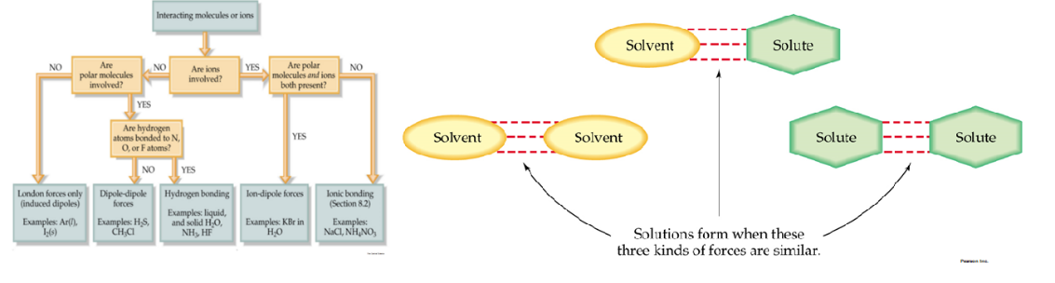
Practice Problems:
- Determine whether the following substances dissolve in CCl₄ (nonpolar)or H₂O (polar)?
C₇H₁₆ | Nonpolar, CCl₄
Na₂SO₄ | Ionic, H₂O
HCl | H₂O
C₂H₅OH | H₂O
I₂ | CCl₄
SiCl₄ | CCl₄

- Calculate the concentration of the following aqueous solutions in molarity (M).
- 1.25 moles glucose in 7.40 L solution
M= number of moles of solute/ Liters of solution
= 1.25 moles/ 7.40 L = 0.17 M

- 4.28 g (NH₄)₂S in 0.300 L solution
M = number of moles of solute/ Liters of solution
Mass moles (MM)
4.28 g (NH₄)₂S x 1 mol/ 68 g = 0.063 mol (NH₄)₂S
M= 0.063 mol (NH₄)₂S/ 0.300 L = 0.209 M (NH₄)₂S

- Calculate the concentration of the following aqueous solution in vol %(v/v)?

- 450 mL CH₃CH₂OH in 1 L solution
%v/v = volume of solute/ volume of solution x 100
1 L= 1000 mL
450 mL/ 1000 mL x 100 = 45%
0.45 L/ 1 L x 100= 45%

- How many moles of Na⁺ are present in 343 mL of a 1.27 M solution of Na₂SO₄?
Na₂SO₄ 2Na⁺ + SO₄²⁻

M= number of moles of solute/ Liters of solution
M= 1.27 x 0.343 L= mol 0.436 mol
2 (0.436)= 0.871 mol

- How many milliequivalents (mEq) of chloride are contain in a sample that is determined to contain 0.725 g of chloride ion?
1 Eq = 1000 mEq
1 Eq Cl⁻ = 35.43 g

0.725 g Cl⁻ x 1 Eq Cl⁻/ 35.43 g Cl⁻ = 0.020 Eq Cl⁻ x 1000 mEq/ 1Eq = 20.46 mEq

- How many mL of 0.105 M (# of moles of solute/ L of solution) NaNO₃ are needed for an experiment that requires 0.005 moles of NaNO₃?

0.005 mol NaNO₃ x 1 L of solution/ 0.105 mole NaNO₃ = 0.0476 L = 47.6 mL

- If 10.0 mL of 12 M HCl is diluted to 600 mL, what is the new concentration of the acid?
M₁ x V₁ = M₂ x V₂

M₂ = M₁ x V₁ / V₂
= 12 x 10.0 mL / 600 mL = 0.2 M

- How many milliliters of 0.150 M BaCl₂ are needed to react completely with 35.0 mL of 0.200 M Na₂SO₄ according to the following equation?

BaCl₂(aq) + Na₂SO₄(aq) 2NaCl(aq) + BaSO₄(s)

0.035 L x 0.200 mol/ L = 0.007 mol Na₂SO₄

Mole to Mole Relationship

0.007 mol Na₂SO₄ x 1 mol BaCl₂ / 1 mol Na₂SO₄

0.007 mol BaCl₂ x 1 L/ 0.150 mol BaCl₂ = 0.047 L or 47 mL

