Salt Lake Community College, Chemistry Department
Chem 1110 Workshop 11
Topic: Gases Part II Objective:
- To be able to understand the ideal gas law to predict and explain how gases respond to changes in pressure and volume
- To be able to use the concept of partial pressures of gases

Ideal gas Law:

The relationships among the four variables P, V, T, and n for gases can be combined into a single expression called the ideal gas law. The constant R is called the gas constant. Its value depends on the units chosen for pressure.
R = 0.0821 L•atm/mol•K
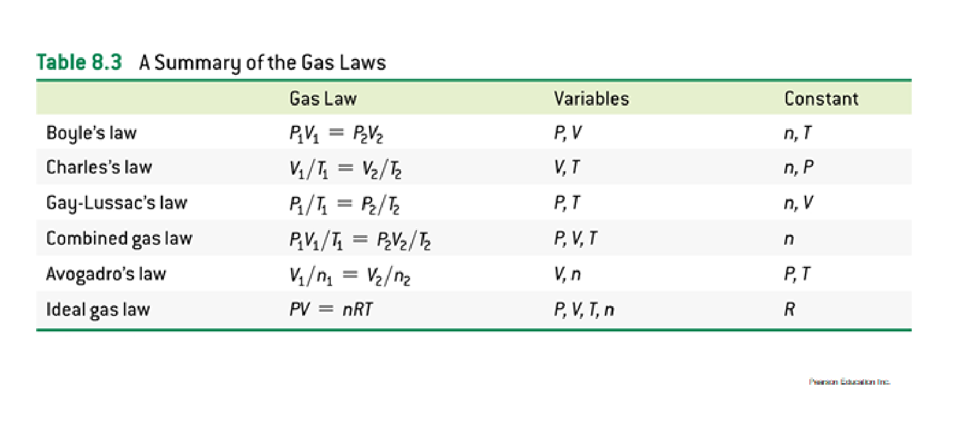
Partial Pressure and Dalton’s Law:
In any mixture of gases, the total pressure is the sum of the partial pressures of each gas present. The pressure exerted by each gas is the same as if it were the only gas present.
Ptotal = Pgas 1 + Pgas 2 + Pgas 3 Practice problems:
- Find the pressure exerted by 1.40 g of N₂ (g) in a 800 cm³ container at 0°C.
PV= nRT
P= ?
V= 800 cm³, 1 mL= 1 cm³ 800 mL 0.800 L
T= 0°C, 273 K
Mass= 1.40 g MM_{N2} = 28 g/mol = 0.05 mol
Solve for P: P= nRT/ V Answer: P= 1.40 atm
- The reaction of 75.0 g of iron (III) sulfide with excess of HCl will produce what volume of a gas at 0.993 atm and 293 K?

Chemical equation: Fe₂S₃ + 6 HCl 2 FeCl₃ + 3 H₂S
Use the balanced chemical equation to determine the number of moles of gas that will be produced.

75 g x 1 mol/ 208 g x 3 mol H₂S / 1 mol Fe₂S₃ = 1.08 mol H₂S
Rearrange the ideal gas law and solve for V: V= nRT/ P
Answer: V= 26.2 L

- If 87.5 g of gas X exerts a pressure of 2.00 atm in a 30.0 L container at 27 °C (300 K), find the molecular weight of gas X?
Method 1: PV= mass/MMxRT
Rearrange the formula and solve for MM
MM= mass x RT/ PV 87.5 x 0.0821 x 300/ 2.00 x 30.0 = 35.9 g/mol
Method 2: Use the ideal gas law and solve for n:
n= PV/ RT 2.00 x 30.0/ 0.0821 x 300 = 2.44 mol
MM= mass(g) / mol(n) 87.5 g/ 2.44 mol = 35.9 g/mol
- A mixture of gases contains 1.25 moles of N₂, 2.05 moles H₂, and 3.63 moles NH₃. If the total pressure of the mixture is 2.35 atm, what is the partial pressure of each component?
n_{Total} = 1.25 mol + 2.05 mol + 3.63 mol = 6.93 mol
n_{N2}/ n_{Total} = P_{N2} / P_{Total}
P_{N2}= P_{Total} x n_{N2}/ n_{Total} 0.424 atm
P_{H2}= P_{Total} x n_{H2}/ n_{Total} 0.695 atm
P_{NH3}= P_{Total} x n_{NH3}/ n_{Total} 1.23 atm

- Which of the assumptions of the kinetic-molecular theory best explains Dalton's law of partial pressures?
  - Gas molecules move at random with no attractive forces between them.
  - The velocity of gas molecules is proportional to their Kelvin temperature.
  - The amount of space occupied by a gas is much greater than the space occupied by the actual gas molecules.
  - In collisions with the walls of the container or with other molecules, energy is conserved.
  - Collisions with the walls of the container or with other molecules are elastic.

