Salt Lake Community College, Chemistry Department
Chem 1110 Workshop 11
Topic: Gases Part I
Objective:
- To understand and use the several individual gas laws, the combined gas law, and the ideal gas law to predict and explain how gases respond to changes in pressure and volume
- Boyle’s Law: Charle’s Law: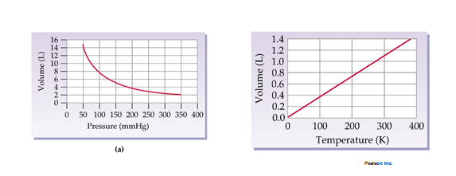

- Avogadro’s Law:
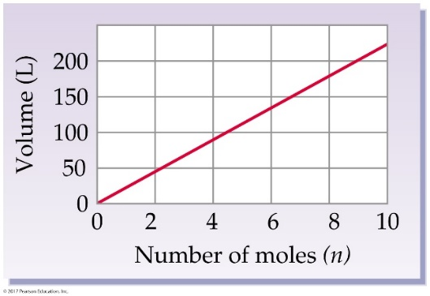
Practice Problems:
- Volume and pressure are ________ proportional.
- directly
- inversely
- all of the above
- none of the above

2. According to Avogadro's Law, the volume of a gas will ________ as the ________ is increased while the ________ are held constant.
- increase; number of moles; pressure and temperature
- decrease; number of moles; pressure and temperature
- increase; temperature; pressure and number of moles
- decrease; pressure; temperature and number of moles
- increase; pressure; temperature and number of moles
- If the temperature of a 1.75 liter (V₁) sample of gas is changed from 30.0°C (T₁ to T₂) 20.0°C at constant pressure, what will be the new volume?
Answer (Charles Law 1.69 L)

- What is the new volume of a balloon originally at 755 torr and 5.00 L is placed in a container in which the pressure is increased to 1.25 atm?
Answer: (Boyles’s Law P₁V₁= P₂V₂ 3.97 L)

- A 6.3 L sample of helium gas stored at 25 °C and 1.0 atm pressure is transferred to a 2.0 L tank and maintained at a pressure of 2.8 atm. What temperature is needed to maintain this pressure?

Combined gas Law : P₁V₁/T₁= P₂V₂/T₂
P₁= 1.0 atm
V₁= 6.3 L
T₁= 25 C + 273 = 298 K

P₂= 2.8 atm
V₂= 2.0 L
T₂= ?

Answer (264.8 K)
- Which of the following is the definition of standard temperature and pressure?
- 273°C and 760 torr
- 298 K and 1 atm
- 273 K and 760 mm Hg
- 0 K and 1 atm

