Salt Lake Community College, Chemistry Department
Chem 1110 Workshop 9
Topic: Thermodynamics
Objective:
- To be able to explain what factors influence energy loss or gain during reactions
- To understand the relationship between free-energy, enthalpy, and entropy changes in reactions
- To understand the concept of equilibrium and relate it to chemical reactions
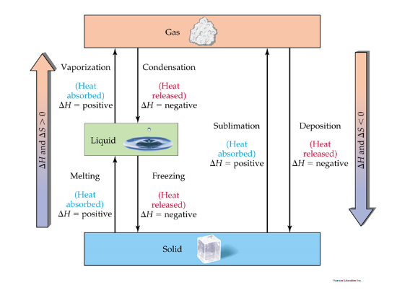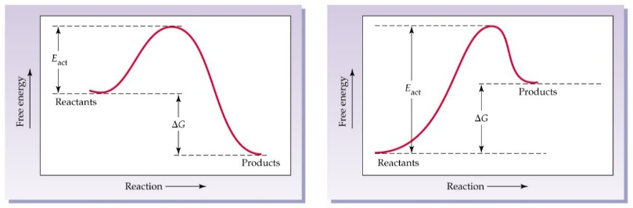
Effects of Temperature, Concentration, and Catalysts on Reaction Rates:
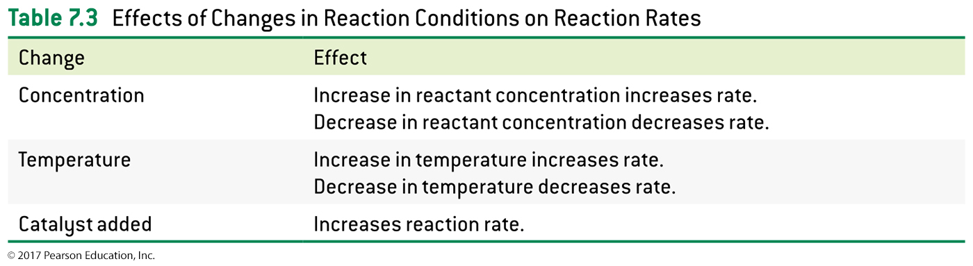
Practice problems:
1. True (T) or false (F)?
- If the heat is transferred from the surrounding to the system and the work is done by the surroundings on the system, ΔE > 0__T_____.
2. 1. Indicate the sign of the enthalpy change, ΔH, in each of the following processes, P = constant:
- Baking Bread (endothermic, ΔH = +)
- Burning a Candle (exothermic, ΔH = -)
- an ice cube melts (endothermic, ΔH = +)
3. Calculate the change of internal energy of a system, ∆E, if 0.010 kJ of heat is added to this system and the system does 20 J of work on the surroundings. Be careful with the units!
∆E= q + w q= 10 J, w= -20 J
∆E= 10 J- 20 J= -10 J
4. Calculate the amount of heat transferred when 1.60 kg of CH₃OH(g) is produced during the following reaction
CO(g) + 2H₂(g) → CH₃OH(g) ΔH = -90.7 kJ
1.60 Kg CH₃OH x 1000 g / 1 kg = 1600 g CH₃OH
MM => CH₃OH= 12+ 4(1) + 16 = 32 g/mol
1600 g CH₃OH x 1 mol/ 32 g = 50 mol CH₃OH
50 mol CH₃OH x -90.7 KJ/ mol= - 4535 KJ
5. Use ΔH° = -890 kJ to find the heat produced when 4.80 g of CH₄ gas is burned in O₂ at 25° C and 1 atm?
4.80 g CH₄ x 1 mol/ 16 g = 0.3 mol
0.3 mol CH₄ x -890 KJ/ 1 mol= -267 KJ
6. Consider the reaction shown:

N₂ + O₂ → 2 NO ΔH = 43.2 kcal

When 50.0 g of N₂ react, ___77.1_____ kcal will be _consumed______ (produced or consumed).
50.0 g N₂ x 1 mol/ 28 g N₂ = 1.79 mol x 43.2 Kcal/ 1 mol= 77.1 Kcal
7. Write the equilibrium equations for the following reactions:
- 2CO(g) + O₂(g) 2CO₂(g) K= [CO₂]²/ [O₂][CO]²
- 3O₂(g) 2O₃(g) K= [O₃]²/ [O₂]³
8. For the following reaction: PCl₅(g) ⇄ PCl₃(g) + Cl₂(g) with ΔH° = 90.0 kJ in which direction will the equilibrium shift when: (possible answers: left, right, no shift)
(a) Cl₂(g) is removed? __right______
(b) PCl₃(g) is added? __left_______
9. 2 Al₂O₃ (s) → 4 Al(s) + 3 O₂ (g) ΔG = +138 kcal
Consider the contribution of entropy to the spontaneity of this reaction. As written, the reaction is ________, and the entropy of the system ________.
a) spontaneous; increases
b) spontaneous; decreases
c) non-spontaneous; increases
d) non-spontaneous; decreases
e) non-spontaneous; does not change

10. Which statement best describes the way a catalyst works?
a) It decreases the value of ΔH.
b) It increases the value of ΔH.
c) It decreases the value of Eact.
d) It increases the value of Eact.
e) It increases the value of ΔG

