Salt Lake Community College, Chemistry Department
Chem 1110 Workshop 8
Topic: Mole and Mass Relationship
Objective
- Molecular and Empirical Formula
- Molecular Weight vs. Formula Weight
- Stoichiometry
- Grams of reactants converted to moles and Moles of product converted back to grams
- Calculation of relative quantities of reactants and products

Molecular and Empirical Formula
- Empirical formula: the formula of a compound with the simplest whole number ratio of elements involved in the compound- Empirical Formula for Glucose (C₆H₁₂O₆) is CH₂O
- Molecular formula: the types and actual number of atoms in a compound Glucose (C₆H₁₂O₆)
Molecular Weight vs. Formula Weight
- Given the molecular formula of a compound, we find the molecular weight by finding the sum of the masses of all the atoms in the compound
- The mass of individual atoms is found on the Periodic Table and is given in amu
- Examples
  - Sodium chloride: 22.99 amu + 35.45 amu = 58.44 amu
Stoichiometry
- As defined by Ebbing "calculation of the quantities of reactants and products involved in a chemical reaction"
- Note: a balanced chemical equation is essential to stoichiometry; a knowledge of molar masses is often also necessary
Grams to moles, mole to mole and Moles to grams conversion:

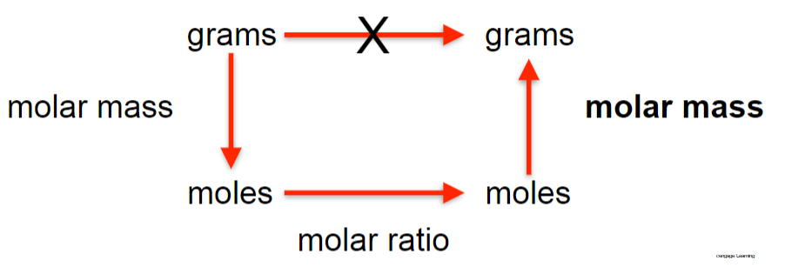
Practice Problems:
  - Please fill the following tables
Molecular Compounds | Molecular Weight
Cl₂ | 2(35)= 70 amu
H₂O | 2(1)+ 16= 18 amu
NH₃ | 14+ 3(1)= 17 amu

Ionic Compounds | Formula Weight
NaCl | 23+ 35= 58 amu
MgBr₂ | 24+ 2(80) = 184 amu
BaS | 137 + 32 = 169 amu

1 Mole | Molar Mass
Mg(NO₃)₂ | 24 + 2(14) + 6(16)= 148 g/mol
Br | 80 g/mol

- Convert 54.0 g of H₂O to moles of H₂O.
54.0 g H₂O x 1 mol/ 18 g= 3.0 mole of H₂O

- Find the mass of 0.647 moles of CO₂.
Step 1: MM CO₂ = 12 + 32= 44 g/mol
Step 2: 0.647 mol CO₂ x 44g/ mol= 28.5 g of CO₂

- How many moles of Ca²⁺ and Cl⁻ ions are there in 1 mole of CaCl₂?
1 mole of Ca²⁺ : 2 moles of Cl⁻
- How many moles of copper would be produced from 6 moles of copper (I) oxide according to the following equation:
Cu₂S _{(s)} + 2Cu₂O (s) 6Cu (s) + SO₂ (g)
6 mole of Cu₂O x 6 mol Cu/ 2 mol Cu₂O = 18 mol Cu
- If 30.4 grams of CO₂ can be produced in the reaction of C₂H₂ with O₂ to form CO₂ and H₂O, how many grams of H₂O can be produced in the reaction?
Combustion Reaction

2(C₂H₂ +2.5 O₂ 2CO₂ + H₂O)
Step 1: balance the chemical equation: 2C₂H₂ +5 O₂ 4CO₂ + 2H₂O
Step 2: Covert mass moles (using molar mass)
30.4 g x 1 mole/ 44 g= 0.70 mol CO₂
Step 3: mole to mole relationship
0.70 mol CO₂ x 2 mole H₂O/ 4 mole CO₂ = 0.35 mol H₂O
Step 4: mole to mass (MM)
0.35 mol H₂O x 18 g/ 1 mole H₂O= 6.3 g H₂O
- Elemental iron is produced according to the following reaction:
Fe₂O₃(s) + 2Al(s) ---> Al₂O₃(s) + 2Fe(s)
Limiting reactant: Fe₂O₃
If 5.34 g Fe₂O₃ is allowed to react with excess Al, what is the theoretical yield (g) of elemental iron for this reaction?
Step 1: balance the chemical equation.
Step 2: mass (g) moles (Molar Mass)
5.34 g Fe₂O₃ x 1 mole/ 160 g = 0.0334 mol Fe₂O₃
Step 3: mole mole (based on the balanced chemical equation)
0.0334 mol Fe₂O₃ x 2 mole Fe/ 1 mol Fe₂O₃ = 0.066 mol Fe
Step 4: moles mass (g) (Molar Mass)
0.066 mol Fe x 56 g Fe/ 1 mol Fe= 3.70 g Fe (Theoretical yield)

