Salt Lake Community College, Chemistry Department
Chem 1110 Workshop 7 - Part I
Topic: Chemical Equations
Objective:
- Balancing chemical reactions
- Ways to classify the chemical reactions
- Strong, weak and non-electrolytes

Balancing Chemical Reactions:
- Remember mass balance!
- Use the Periodic Table and a knowledge of polyatomic formulas and charges to select the ratios of ions and how they go together (Empirical Formula)
- There is a difference between the subscripts in molecular formulas and the coefficients of balanced chemical equations
Ways to classify chemical Reactions:
Chemical Reactions
Synthesis Reactions
Decomposition Reactions
Combustion Reactions
Oxidation- Reduction Reactions
Neutralization Reactions (Acid- Bases Reactions)
Double Displacement Reaction (Precipitation Reactions)

Strong, weak and non-electrolytes:
- Strong electrolytes - dissociate (ionize) ~100%. This includes all ionic compounds and strong acids and bases.
- Weak electrolytes - dissociate less than 100%, usually 1-10% or less. The most common weak electrolytes are the organic acids
- Nonelectrolytes - do not dissociate. This includes all covalent compounds except organic acids and bases
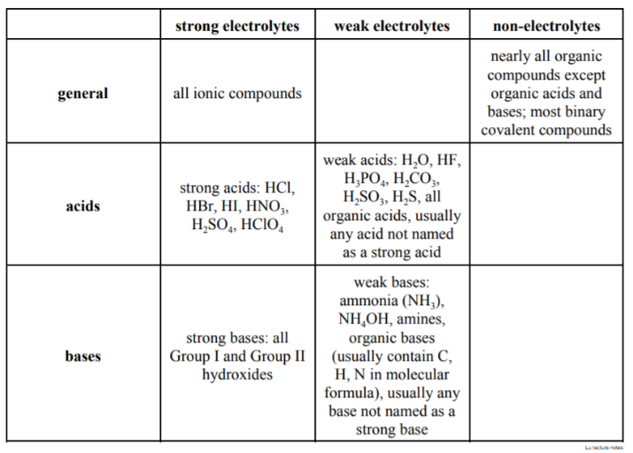
Practice Problems:
1. Which statement regarding balanced chemical equations is not true?
- The number of each kind of atom must be the same on each side.
- Coefficients are used in front of formulas to balance the equation.
- Subscripts may be changed to make an equation simpler to balance.
- When no coefficient is written in front of a formula, the number "one" is assumed.
- Reactants are written to the left of the arrow.
- Balance the following reactions:
- N₂ (g) + 3H₂ (g) → 2NH₃ (g)
- 4Al (s) + 3O₂ (g) → 2Al₂O₃ (s)
- C₃H₈ (g) + 5O₂ (g) → 3CO₂ (g) + 4H₂O (g)
- Fe₂O₃ (s) + 3CO (g) → 2Fe (s) + 3CO₂ (g)
- Which is the correct equation for the reaction of magnesium (Mg) with hydrochloric acid (HCl) to produce hydrogen (H₂) and magnesium chloride (?

- Mg + 2 HCl → H2 + MgCl₂
- Mg + HCl → H + MgCl
- 2 Mg + 6 HCl → 3 H2 + 2 MgCl₂
- Mg + 2 HCl → 2 H + MgCl₂
- Mg + 3 HCl → 3 H + MgCl₂

- Which reaction is an example of an acid-base reaction?
a) H₂CO₃ (aq) → H₂O(l) + CO₂ (g)
b) H₂SO₄ (aq) + Ca(OH)₂ (aq) → CaSO₄ (aq) + 2 H₂O(l)
c) 6 HCl(aq) + 2 Al(s) → 2 AlCl₃ (aq) + 3 H₂ (g)
d) FeCl₃ (aq) + 3 KOH(aq) → Fe(OH)₃ (s) + 3 KCl(aq)
e) 2 Hg(l) + O₂ (g) →2 HgO(s)

- The following reaction can be classified as what type(s) of reaction(s)?

2 Al(OH)₃(aq) + 3 H₂SO₄(aq) → Al₂(SO₄)₃(s) + 6 H₂O(l)

- precipitation
- acid-base neutralization
- redox reaction
- combustion
- both A and B

- Classify the following as a precipitation, an acid-base neutralization, or a redox reaction (rxn).
- Ca(OH)₂(aq) + 2HBr(aq) → 2H₂O(l) + CaBr₂(aq)
(Acid-Base neutralization rxn)
- Pb(ClO₄)₂(aq) + 2NaCl(aq) → 2PbCl₂(s) + 2NaClO₄(aq)
(Double displacement rxn, precipitation)
- 2AgNO₃(aq) + Cu(s) → 2Ag(s) + Cu(NO₃)₂(aq)
(Oxidation-Reduction Reaction, Redox rxn)

