Saved Searches in Handshake
Across Handshake, there are many areas in which you can save a search (aka save a report or save filters) so that you do not have to manually input filters each time. You can save searches in the Jobs tab, Student Management tab, Employer tab, Appointments tab, etc and the process to do so is the same across all of Handshake. Below is an example of how to save a search within the Appointments tab, but remember, anywhere that you see these blue buttons at the top of a filters menu, the same steps will apply: 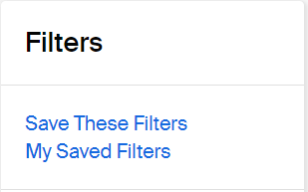

Example - Saved Search on the Appointments tab:
Let’s say you want to run a report of All the appointments You have had In-Person…
- Go to the Appointments tab on the left-hand black menu in Handshake. 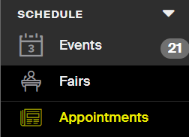
- The Appointments tab will automatically show upcoming appointments, so in order to see ALL appointments (including past ones), scroll to the bottom of the Filters menu and click on the down arrow next to Other, then check the box for Include Past Appointments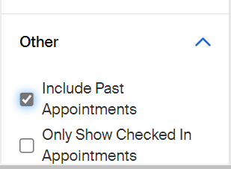
- Then to see only YOUR appointments rather than all coaches’ appointments, scroll to the Filter for Staff Member and either check the box by your name if your name is already showing, or if you don’t see your name you can type it into the “+ Add Staff Member” box and select your name from there.
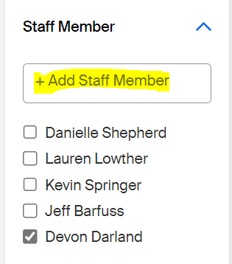
- Next, in order to only show In-Person appointments you had, as opposed to other mediums (like video or phone), scroll to the Filter for Medium and type into the “+ Add Medium” box “In Person – [insert your campus]”
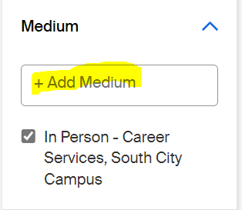
- Now that you’ve got your needed Filters added, you can scroll up to the top of the Filters menu and click the blue link to Save These Filters
- When the window pops up, you can name the Saved Search in a descriptive way so you’ll know what filters were applied and you can fill out the Description section as well with more details if needed (Description is optional)
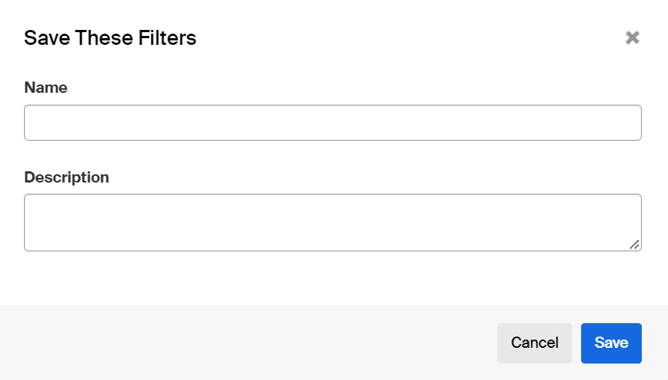
- Then hit the blue Save button. When you want to pull up that same search again without having to individually apply each of those filters, simply go to the top of the Filters menu on the Appointments tab and click on My Saved Filters, and choose whatever you named the search from the list that appears (if you have multiple saved search there).

Note: Whatever saved searches you create in the Appointments tab cannot be accessed by clicking on My Saved Filters from any other tab in Handshake. If you’re on the Jobs tab and click on My Saved Filters, for example, it will only show you the Job searches you’ve saved, not your Appointments searches.

