The front desk does NOT need to check students in for scheduled appointments with a career coach. Simply message the coach on Teams to let them know their student appointment is here. You can see scheduled appointments by clicking on the Appointments tab in the black left-hand menu of Handshake.
The front desk will check students in for DROP-INS. Take the following steps to check a student in for a drop-in:
- Log into your staff account in Handshake.
- Click on Appointments from the left-hand black menu:
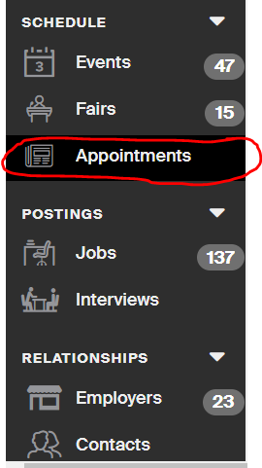
- Click on the Check-in Kiosk tab on the top of the Appointments page. 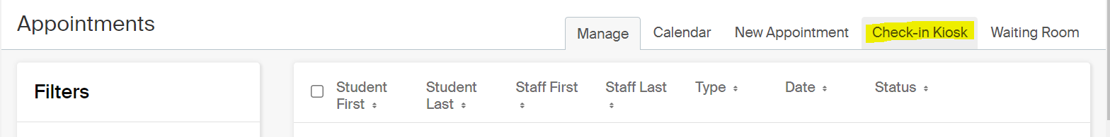
- In the window that pops up, select the campus site you’re at and the same career center location. Do NOT check the box to keep you logged in. (Only ever check the box to stay logged in if you’re opening the Check-in Kiosk on your own computer that you’re not giving students access to, or else they’d be able to access your staff account) The drop-in appointments box should already be checked. Then click the blue Launch Kiosk button.
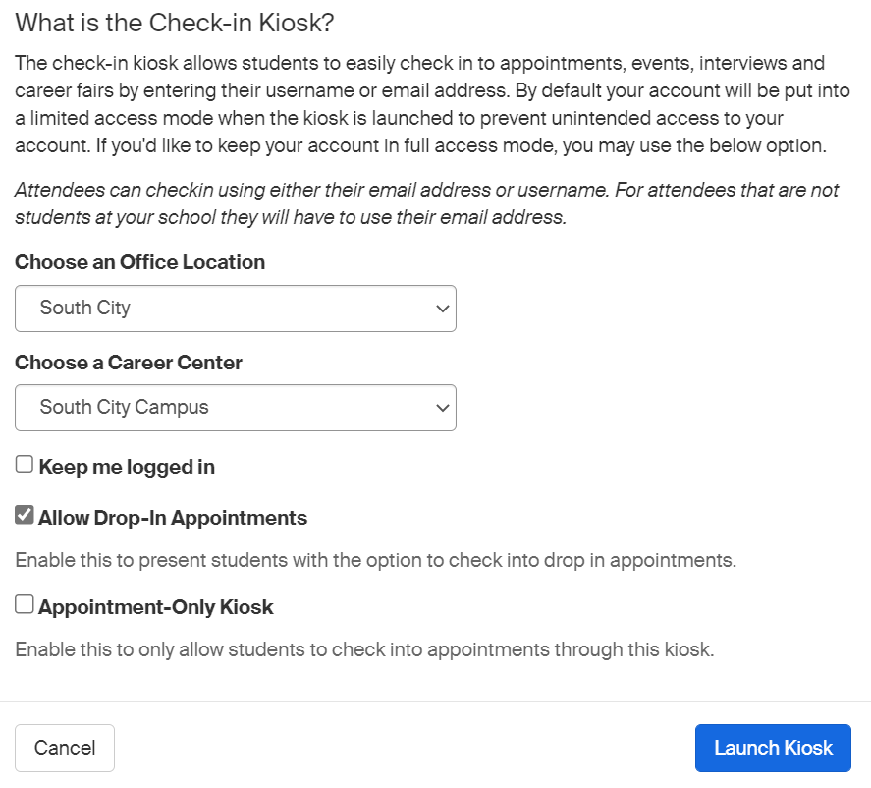
- When a student drops in, you enter their student email into the kiosk and then hit the blue Go button. This will check the student in. 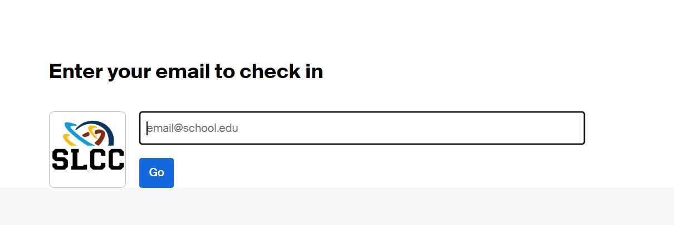

The career coach should have the Waiting Room open on their computer during their drop-in hours. When you check a student in, the coach will hear a ding-dong noise to alert them that a student is in the waiting room so they can come out and greet the student. If the coach does not come meet the student within a few minutes (and they aren’t currently meeting with someone), feel free to send them a quick Teams chat to make sure they know a student is there waiting for a drop-in appointment.

