- Introduction: This manual is a guide to using O*NET Online which summarizes occupations within the following areas: skills, tasks, knowledge, technology work (what type of technology will be required to perform the job), education, and wage within each occupation. O*NET can help identify Green (environmentally friendly), STEM (Science, Technology, Engineering and Mathematics), Bright Outlooks Jobs (occupations are expected to grow rapidly in the next several years or will have large numbers of job openings). O*NET has a crosswalks section which helps use Military experience convert to Civilian (Normal jobs) along with using different Military Codes that classify jobs to (Normal) occupations.
- Warnings/Cautions: Websites change all the time and the layout and steps may change after this creation, but the concepts should stay the same. Not every action on this site will be covered but a general overview.

- Necessary Background: O*NET helps target skills to occupations, information to help build resumes, find additional titles for jobs search, look up occupations by career clusters/industry and growth rate.

- Equipment/Supplies: Computer/Phone or device connected to the internet, internet.
- Steps: This will be a guide on how to use each section of O*NET Online

Step 1: Go to the O*Net Website: https://www.onetonline.org/ the below screenshot shows how it currently looks.
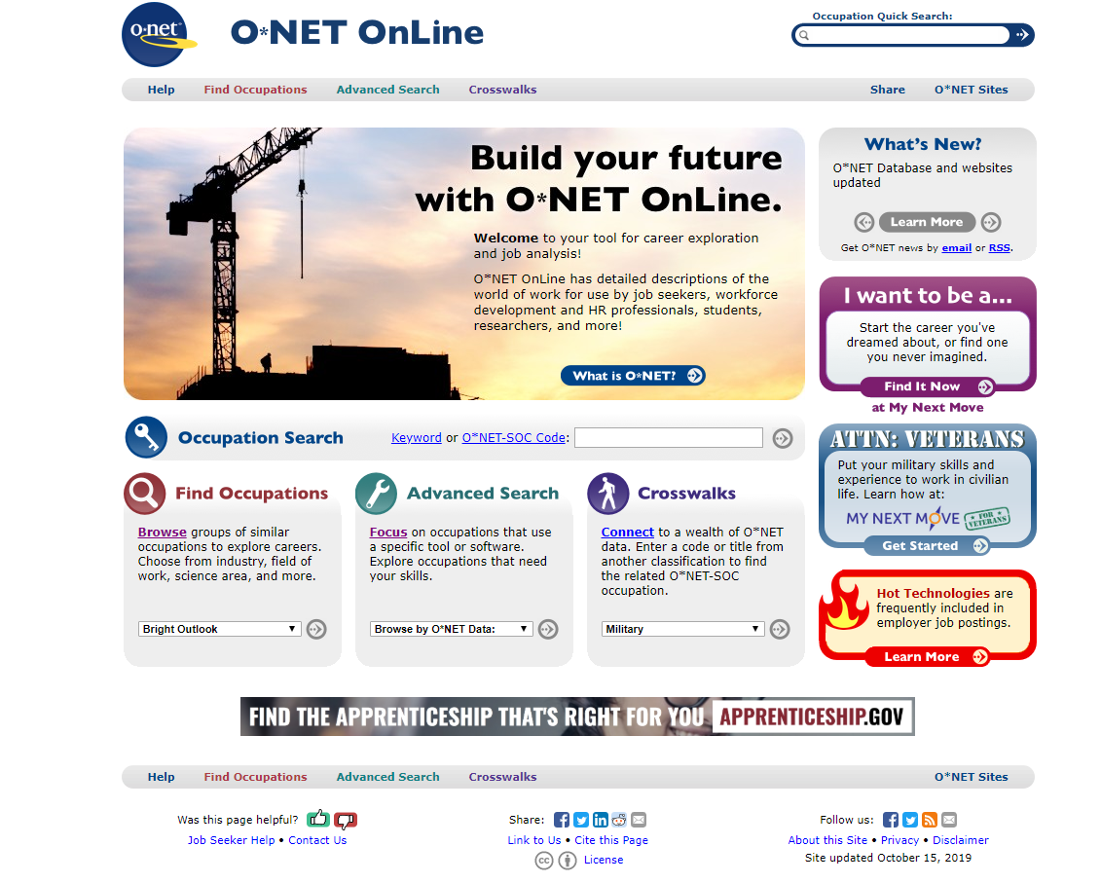

Step 2: To Search for a specific job/occupation type it into the Occupation Search box a keyword or code and click on the arrow on the right side of the box type. See screenshot below
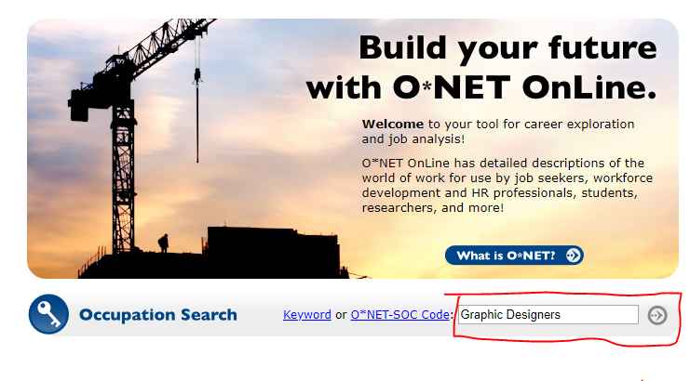
Step 3: Choose the Occupation/keyword/code you put in or review the generated list to see what is closest to your desired occupation. This is a good time to explain to student that there can be several different Jobs within the same degree/major when looking at different occupations for employment. * see below for explanations of symbols in step 5. 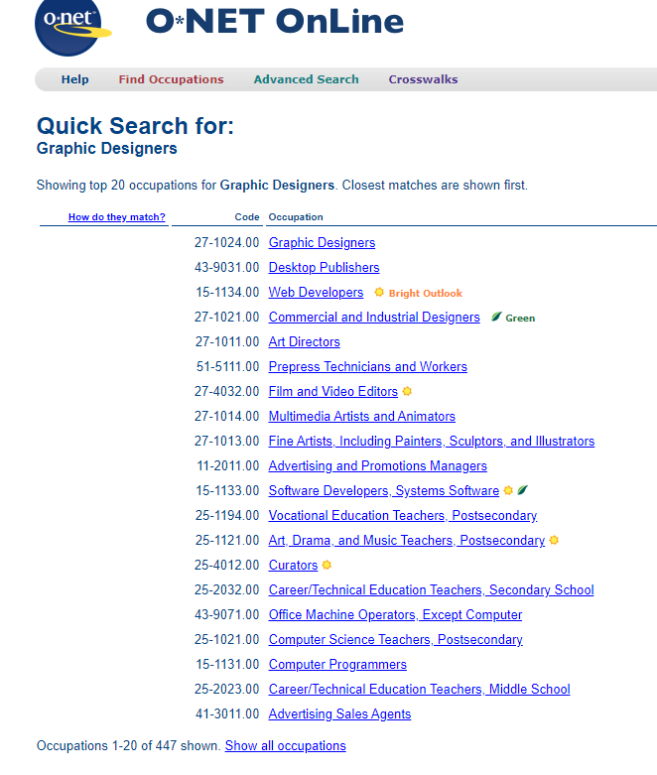
Step 4: Review the Summary Report with students to help them look at the different targeted areas when deciding a major, building a resume, a better idea of what one would do within the occupation and key requirements.

Here is a list of different sections you can review:
- Overview of the Occupation
- Different Job Titles -Use when job searching
- Task for the occupation
- Technology Skills used within the occupations
- Key Knowledge pointes needed
- Top Skills
- Required abilities
- Work Activities by targeted skills
- Detailed Work Activities
- Work Context of what working in the occupation is like
- Job Zone- Breakdown of what the average job requirements are
- Education
- Credentials need to work within the occupation
- Interest codes which is to help you discover you work interest/type
- Work Styles
- Work Values
- Related Occupations
- Wage & Employment Trends
- Job Opening via Link to Career Onestop

Step 5: Find Occupations in groups of similar occupations to explore careers. To search for a specific group, click on the drop-down box and select the group/area you want then click the arrow on the right side of the box type. (See Screenshot below)
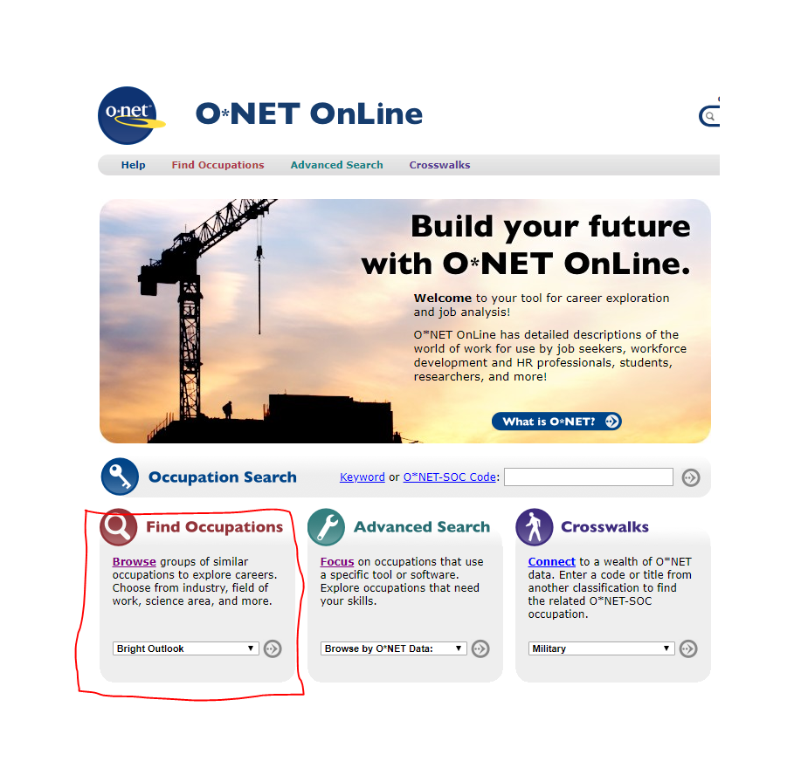

The following groups you can research from the drop-down tab:

- Bright Outlook -Based in Rapid Growth and Numerous Job Openings
- Career Cluster - Contain occupations in the same field of work that require similar skills. Students, parents, and educators can use Career Clusters to help focus education plans towards obtaining the necessary knowledge, competencies, and training for success in a career pathway.
- Green Economy Sector -Occupations targeted for renewable, efficient and regulatory
- Industry - Industries are broad groups of businesses or organizations with similar activities, products, or services. Occupations are considered part of an industry based on their employment.
- Job Family - are groups of occupations based upon work performed, skills, education, training, and credentials.
- Job Zone - are groups of occupations based upon work performed, skills, education, training, and credentials.
- STEM - occupations that require education in science, technology, engineering, and mathematics (STEM) disciplines.

Step 6: Find occupations focused on industries that use a specific tool or software. Explore occupations that need targeted skills. To search for a specific skill, ability or knowledge etc., click on the drop-down box and select the specific skill, ability or knowledge etc., then click the arrow on the right side of the box type. See screenshot below

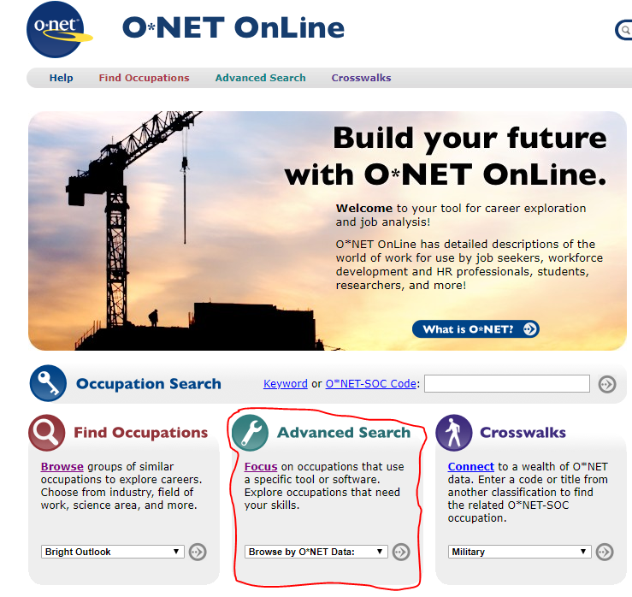

The following arears are the ones that can be researched:
- Browse by O*NET Data for the following
- Abilities
- Interest
- Knowledge
- Skills
- Work Activities
- Work Context
- Work Style
- Work Values
- Related Task Search
- Skills Search
- Technology Skills & Tools
Step 7: Find occupations connected by a code or title from another classification to find the related O*NET-SOC occupation. To search for a code/title, click on the drop-down box and select the code/title then click the arrow on the right side of the box type.
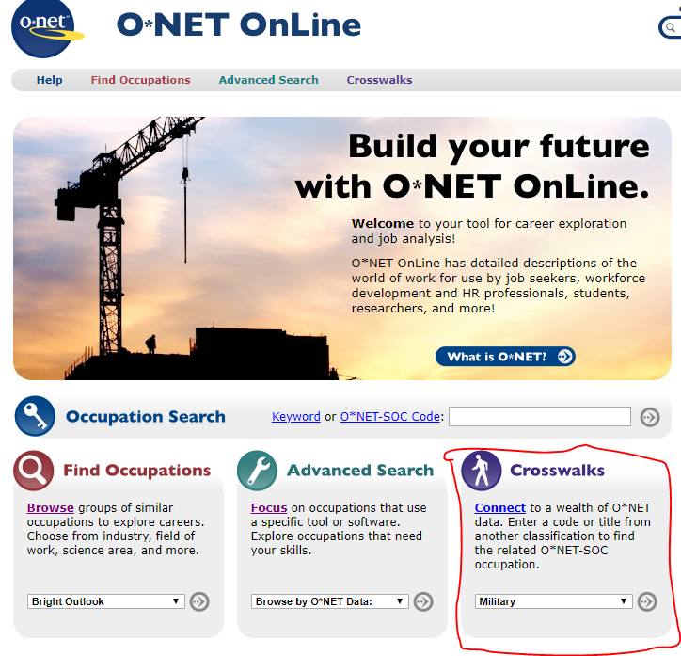
- The following areas are searchable:
- Military Occupational Classification (MOC)
- Classification of Instructional Programs (CIP)
- Occupational Outlook Handbook (OOH)
- Standard Occupational Classification (SOC)
- Dictionary of Occupational Titles (DOT)
- Registered Apprenticeship Partners Information Data System (RAPIDS)

Step 8: Summary -Using each of these searches will lead you to the occupations related and come up with a summary report from step one which can be used to help target educational and career goals.

Did not see any obvious edits-AT
I made some comments above-EB
Made a couple of spelling/grammar edits-JP

