Tornado Forecasting Lab Name ________________________________________________
In this lab, you will use Stuve diagrams (from radiosonde soundings) and a surface weather map to forecast the likelihood of severe thunderstorms and tornadoes in the United States.
L = Lift Surface weather map: Fronts
I = Instability Stuve diagram: Parcel (yellow line), CAPE>1000, Lifted Index (LI<-3)
M = Moisture Stuve diagram: Dewpoint temperature (black dashed line), Precipitable Water (PW>1)
B = Boundaries Surface weather map: Fronts or other boundaries
S = Shear Stuve diagram: Helicity (HEL>250)

Stuve Diagrams
Station Identifier:  CAPE: Parcel Description:  LI:  PW: Dewpoint Description:  HEL: | Station Identifier:  CAPE: Parcel Description:  LI:  PW: Dewpoint Description:  HEL:
Station Identifier:  CAPE: Parcel Description:  LI:  PW: Dewpoint Description:  HEL: | Station Identifier:  CAPE: Parcel Description:  LI:  PW: Dewpoint Description:  HEL:
Station Identifier:  CAPE: Parcel Description:  LI:  PW: Dewpoint Description:  HEL: | Station Identifier:  CAPE: Parcel Description:  LI:  PW: Dewpoint Description:  HEL:
Station Identifier:  CAPE: Parcel Description:  LI:  PW: Dewpoint Description:  HEL: | Station Identifier:  CAPE: Parcel Description:  LI:  PW: Dewpoint Description:  HEL:
Station Identifier:  CAPE: Parcel Description:  LI:  PW: Dewpoint Description:  HEL: | Station Identifier:  CAPE: Parcel Description:  LI:  PW: Dewpoint Description:  HEL:

Surface Weather Map
Using the surface weather map on Canvas, are there any fronts or other boundaries? If yes, where are they located?

Final Analysis
What stations have the highest likelihood for tornadoes and severe thunderstorms? WHY?

Draw concentric circles on the map below indicating where you think there is HIGH, MEDIUM, and LOW chances of severe thunderstorms and tornadoes.

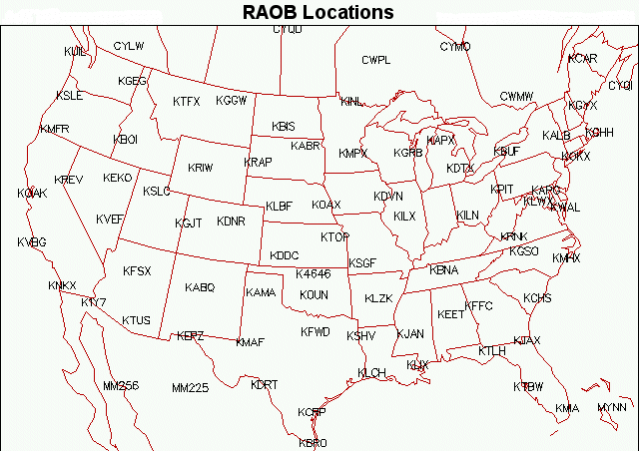

Verification
Use the maps listed under “Verification” on Canvas to determine how close your forecasts were to the actual forecasts produced by the Storm Prediction Center

How close was your forecasts to the actual forecasts?

